3A 3B HUMAN BIOLOGICAL SCIENCE
INVESTIGATION 1

PART A

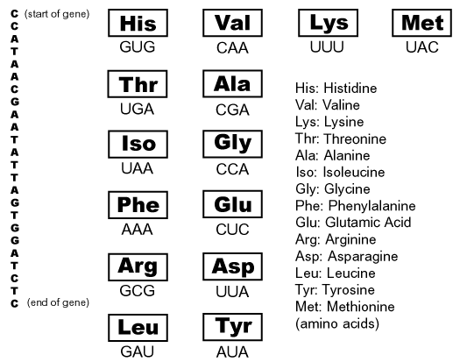

In the above diagram you are given the following information:
1. A single strand of 24 DNA bases representing a gene. The gene starts with the base C and ends with the base C.

2. 14 Transfer RNA (t-RNA) molecules, each consisting of an amino acid (abbreviated by 3 letters within a box), and the base triplet of the corresponding anticodon (outside of the box).

3. The abbreviation and proper spelling of each amino acid.

TASK A: Demonstrate the process of transcription by constructing a strand of Messenger RNA (m-RNA)
(2 marks)
TASK B: Demonstrate the process of translation by identifying each m-RNA codon, and matching it with t-RNA anticodons and stringing them together in this format:
XXX-XXX-XXX-XXX-XXX-XXX-XXX-XXX
(2 marks)
TASK C: Construct the protein by writing the sequences of the amino acids created by t-RNA.
(2 marks)
PART B
Experiment
The preamble below relates to the procedure of the attached experiment. Read both before answering the questions.

In this laboratory experiment students explore how effectively different sunscreens protect yeast cells from damage caused by exposure to ultraviolet (UV) radiation. Students may compare differing SPFs of the same brand of sunscreen or different brands with the same SPF. The experiment utilizes a strain of yeast that lacks several DNA repair mechanisms; UV-induced mutations lead to cell death. The experiment provides data for students to make relative comparisons between sun-screens.

UV radiation harms cells by causing changes in their DNA. While most cells repair this damage, occasionally one does not. This “glitch” can cause a change, called a mutation, in the DNA of a gene. When this gene is transcribed and translated into a protein, the protein may contain an error that causes it to function improperly and lead to cancer. Extensive DNA damage can also lead to skin cells killing themselves. This is one reason why skin peels after a bad sunburn.

Ordinary baker's yeast (Saccharomyces cerevisiae) contains genes for DNA repair that are very similar to human genes with the same function. Therefore we can use yeast as a model system to explore the effects of UV radiation on cells. Like human cells, most yeast cells effectively repair DNA damage caused by UV radiation. However, some yeast strains have mutations that prevent them from making certain types of DNA repairs. Because they cannot repair DNA damage, these cells usually die after exposure to UV radiation. This sensitivity enables us to observe how much DNA damage occurs when the cells are exposed to or protected from UV light.

- Suggest a correctly word hypothesis for this experiment.
(2 marks)
- Identify the independent variable for your hypothesis.
(1 mark)
- Identify the dependent variable for your hypothesis.
(1 mark)
- What are three variables that were (or should have been) controlled?
(3 marks)

- a) What process could be used to determine if there are structural similarities between the gene that repairs mistakes in DNA replication in humans, and genes that do the same thing in yeast?
(1 mark)
b) If there are similarities between the genes for humans and yeast for DNA repair, what conclusion could you draw from that?
(1 mark)

PART C
DNA HYBRIDISATION

Figure 1. Methodology used in DNA hybridisation

Step 1: samples of DNA from different, but related, species.

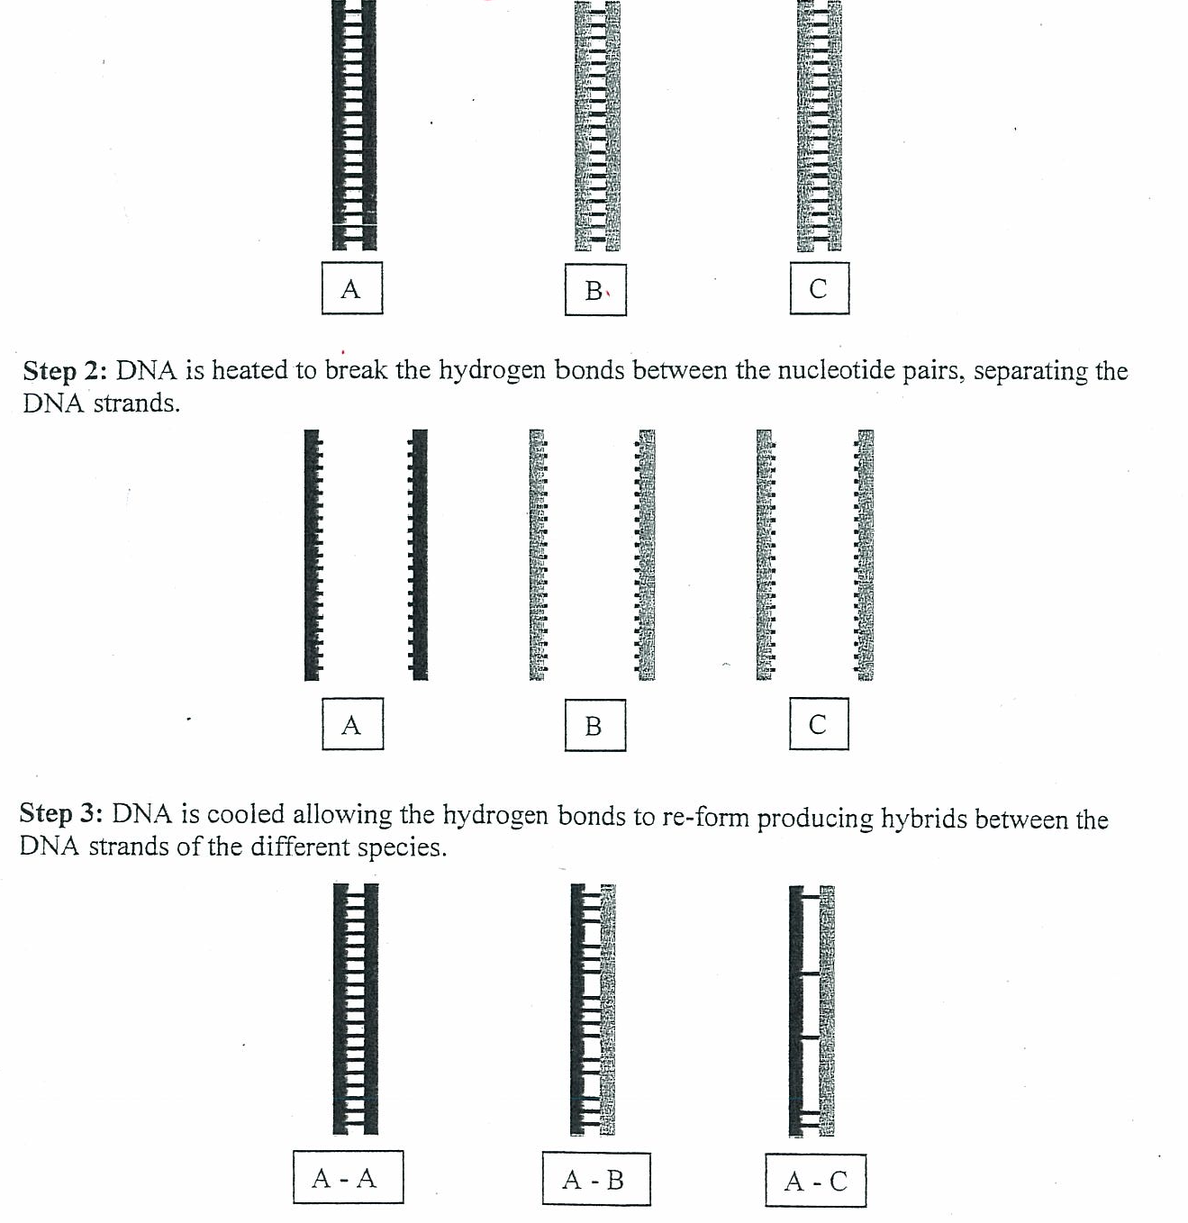

Explain how this information indicates which species are more closely related.

(3 marks)

